Automated Infrastructure Damage Assessment (AIDA 2.0) User Guide

This tutorial contains a walkthrough of how to download unwrapped phase interferograms from the QuakeSim website to be used in the Automated Infrastructure Damage Assessment Tool 2.0 and how to prepare the interferogram to run in the tool.

1. Go to the QuakeSim website (www.quakesim.org). Mouse over Tools and select InSAR Profiles.

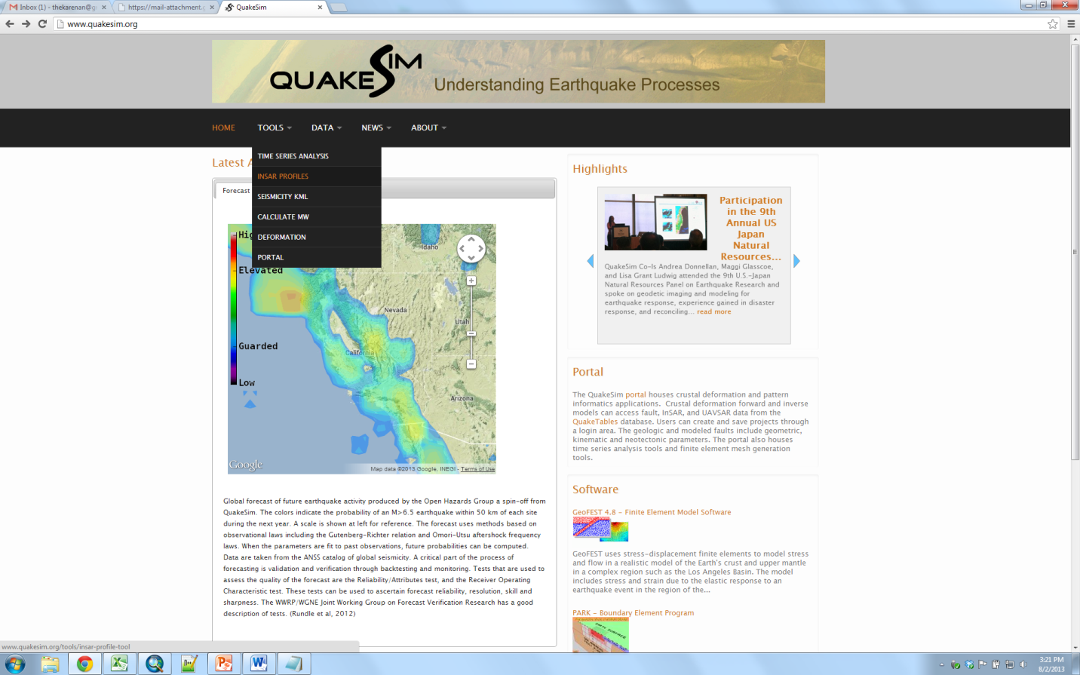

2. Zoom in to the region of interest and select your flight swath. This can be difficult due to the overlap, but click around your region until the desired flight number is displayed in the right side window.

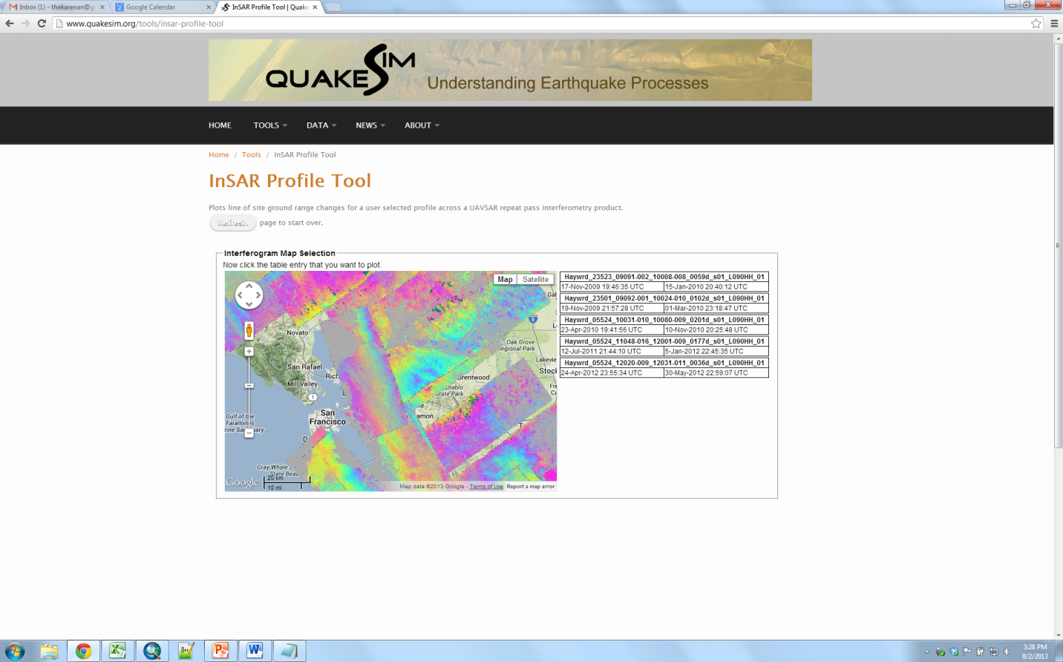

3. Now select the dates for which you are interested in the displacement. The left date corresponds to the first data acquisition and the right date corresponds to the second.

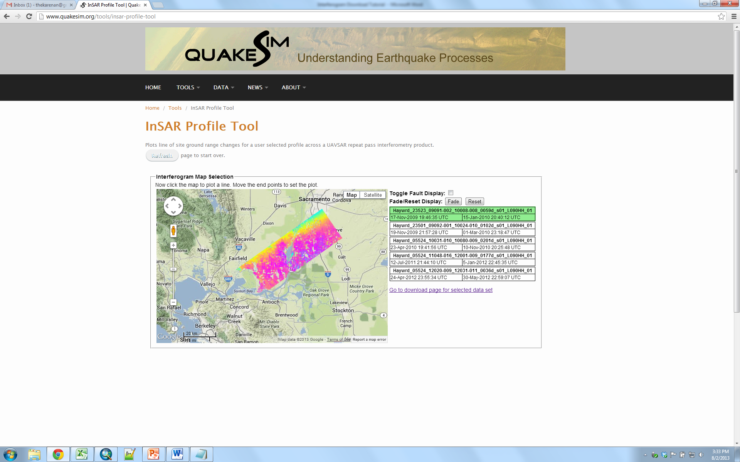

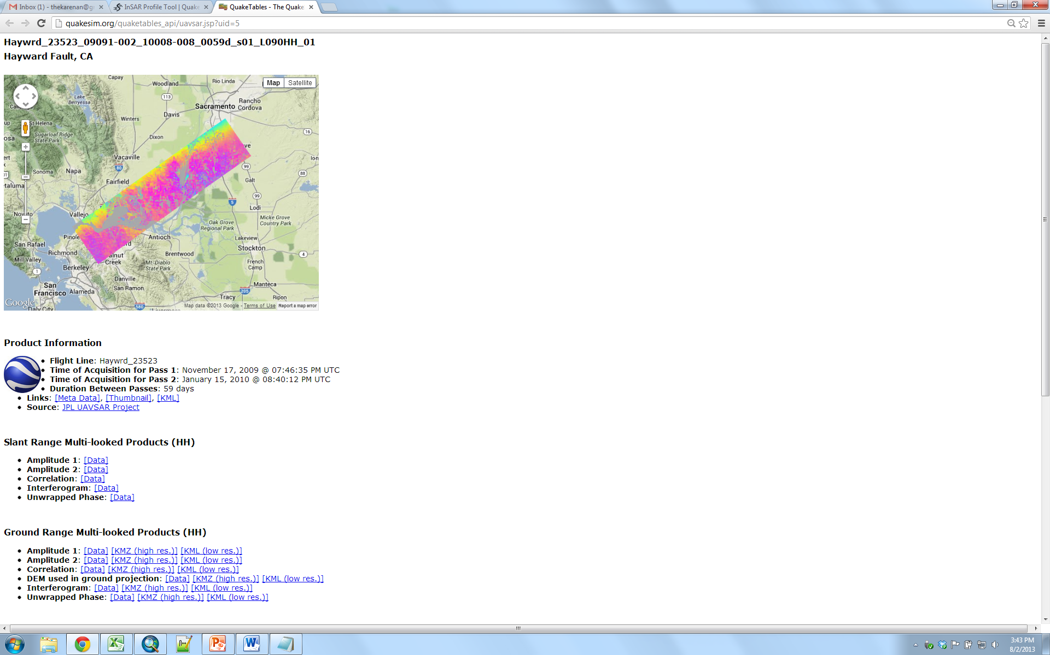

4. Download (right-click and save) the metadata file and Data file for Ground Range Unwrapped Phase (highlighted to the left).

5. Now that you have downloaded the interferogram, use ENVI Classic to create the appropriate header file. Use the PolSAR header tutorial for guidance, but use the “Ground Range Multi-Looked Product Information” lines as your inputs.

6. Open the grd file in ArcMap by selecting the Add Data icon. Use the Identify cursor to choose a zero point that lies outside of areas of deformation. Note the pixel value for your zero point.

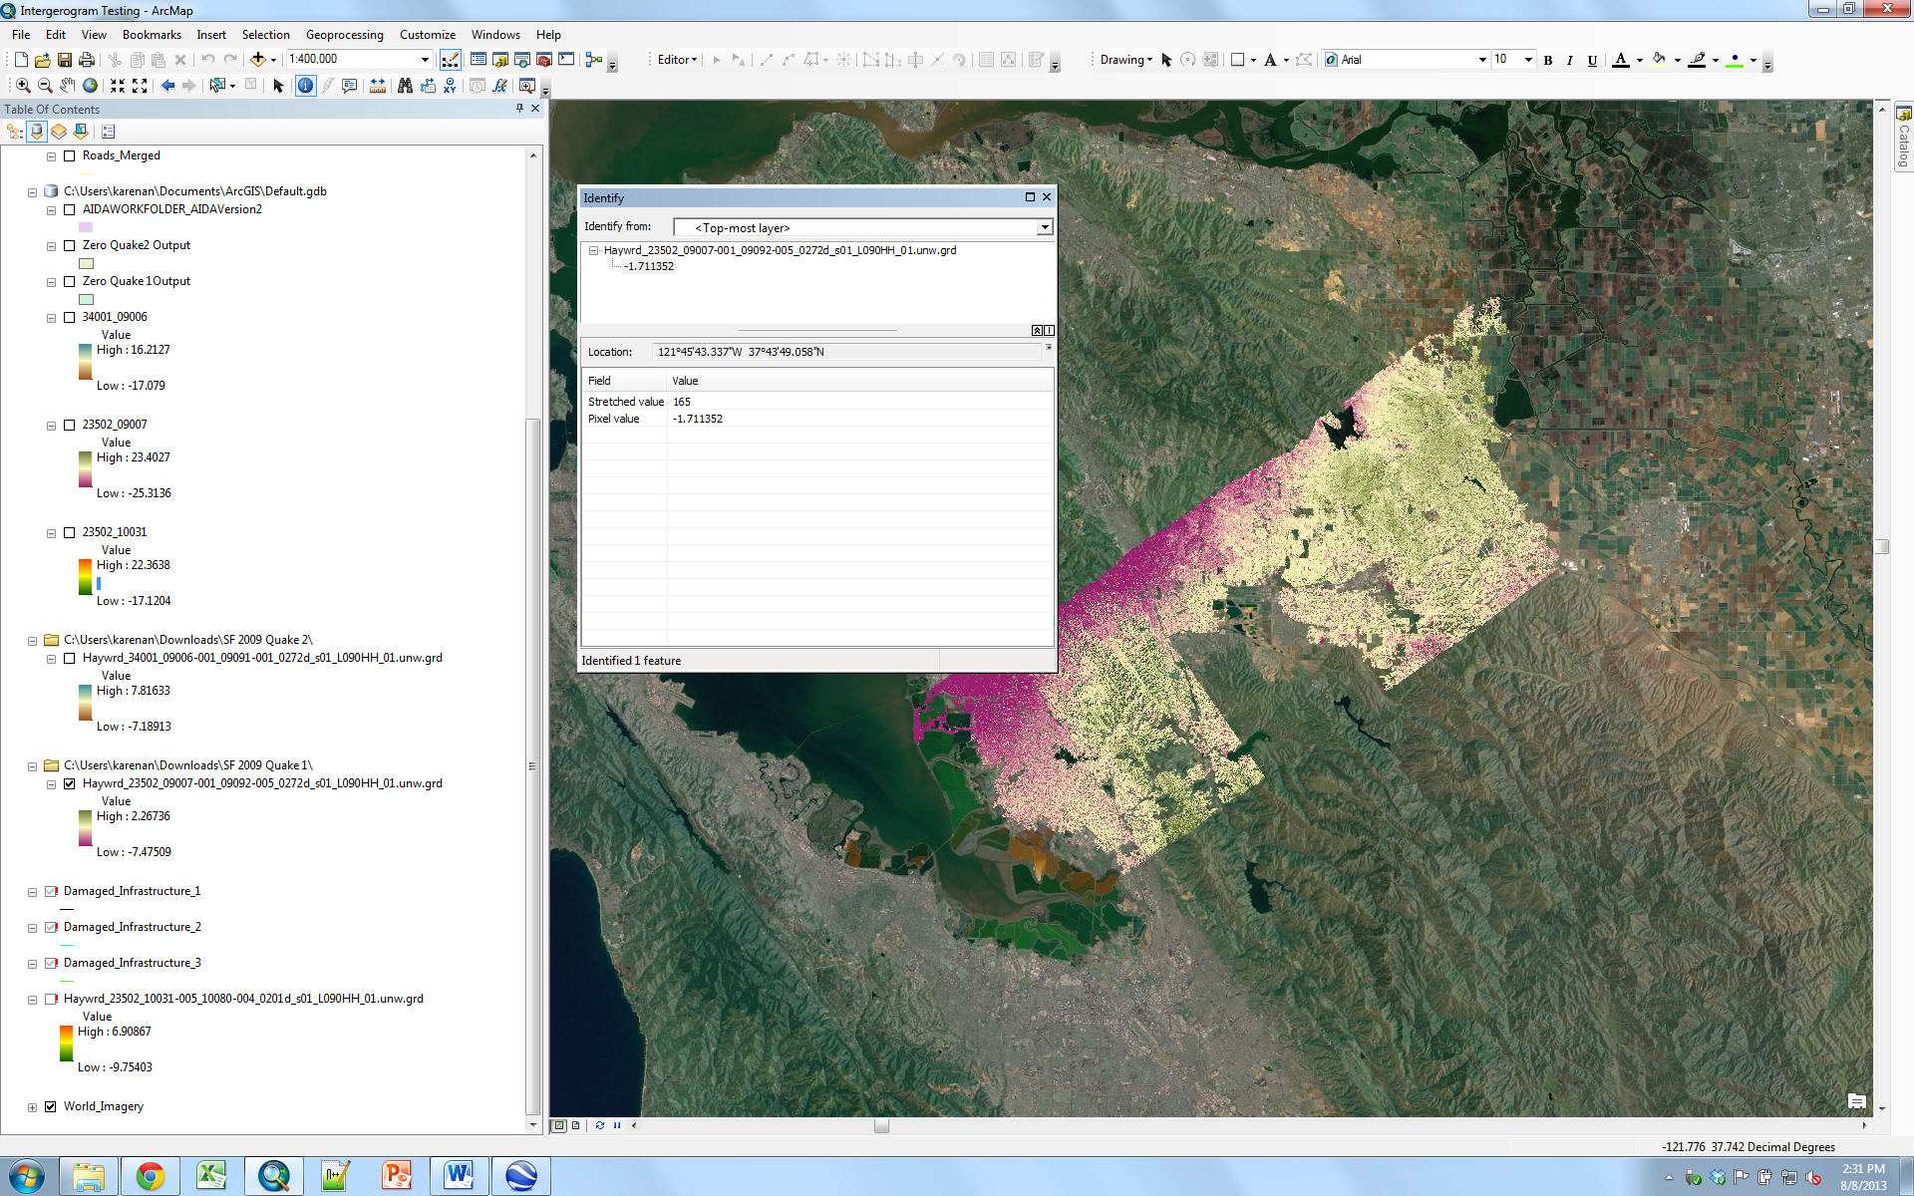

7. Search “minus” in the search toolbar for the Minus (Spatial Analyst) tool. The first input raster should be your interferogram and the constant value 2 is the pixel value for the zero point you have chosen. Output raster is the location and name of this output.

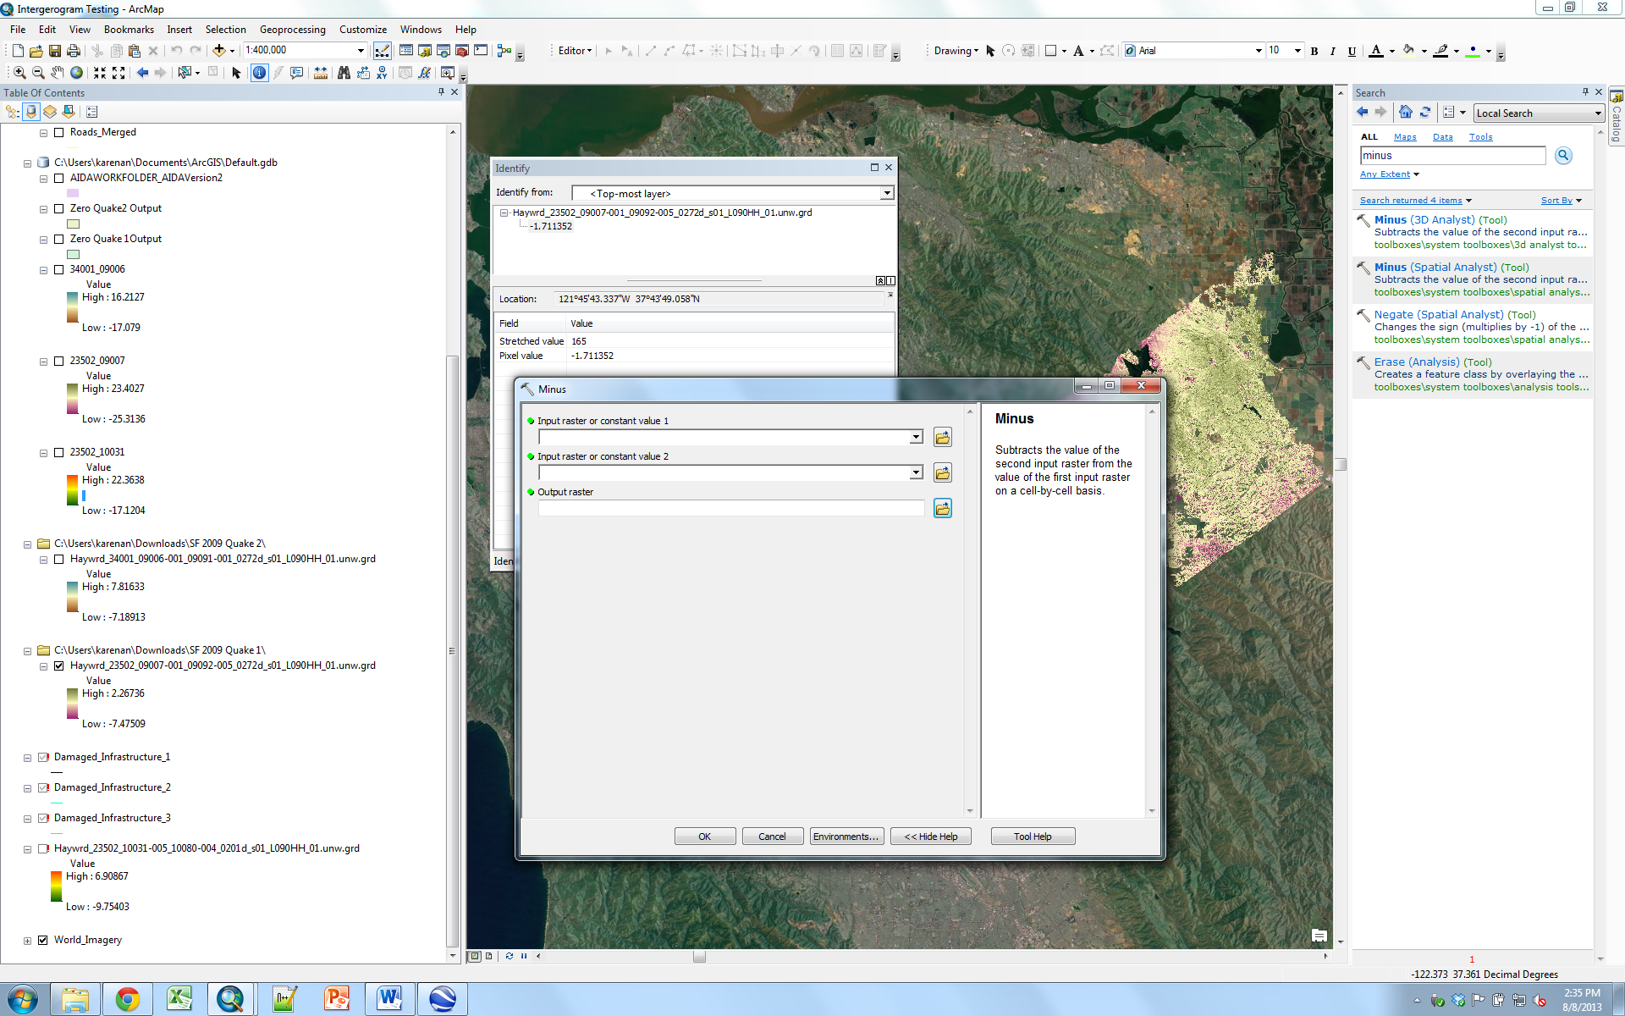

8. Search “times” for the Times (Spatial Analyst Tool). Using the equation below, we can relate the phase value to displacement by multiplying by a constant value. Since we are using L-band, its wavelength is 23.8403545 cm (from annotation file) and this will also be the units for our displacement values. The constant that we will use is: (23.8403545/(4pi)) = 1.89715513187. Copy and paste this value in either input for the Times tool. The other input should be your interferogram after the Minus.

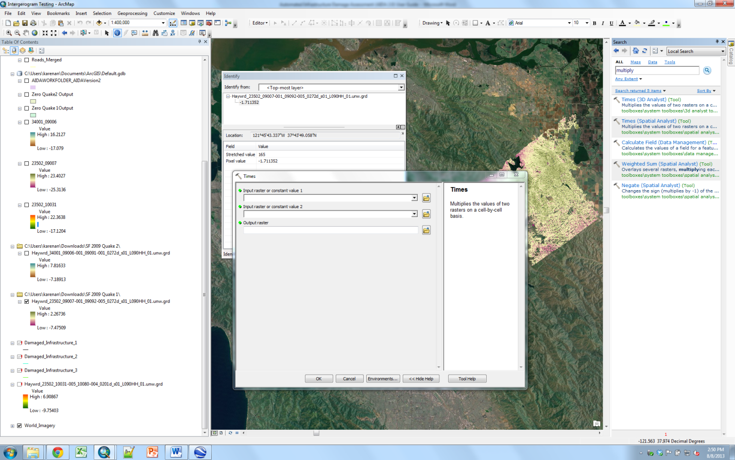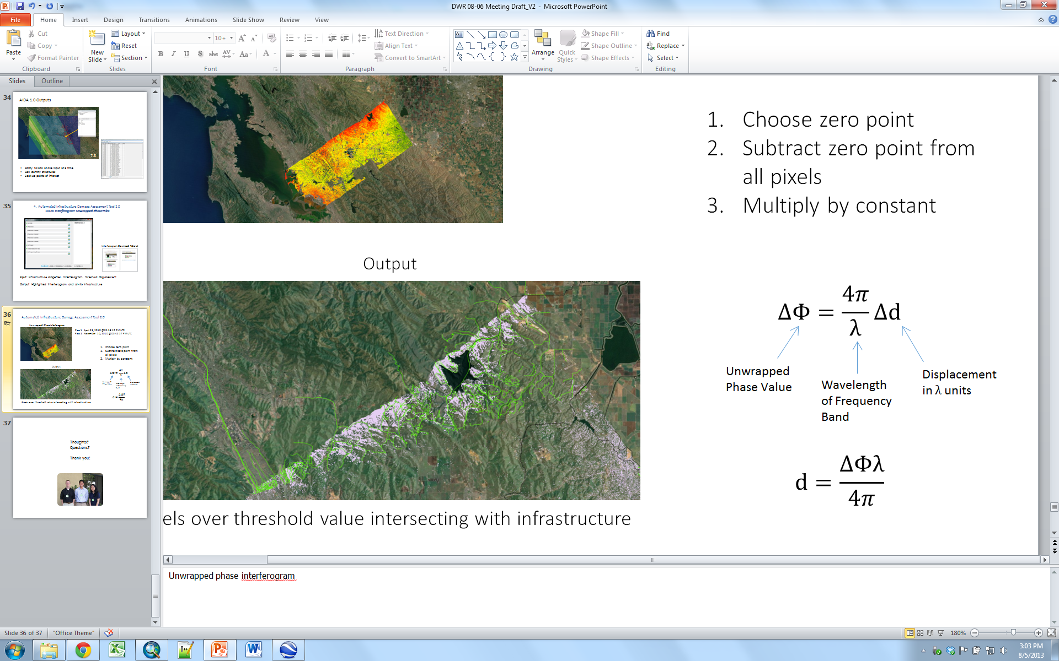

9. Now add the AIDA 2.0 tool to the ArcToolbox. The work folder contains all of the infrastructure inputs. Input the interferogram that you just extracted displacement values for. If difficult to find, export the raster file as a TIFF file by right-clicking and selecting Data>Export Data. Enter the threshold displacement value, as in AIDA 1.0. Lastly, enter the name of your output interferogram.

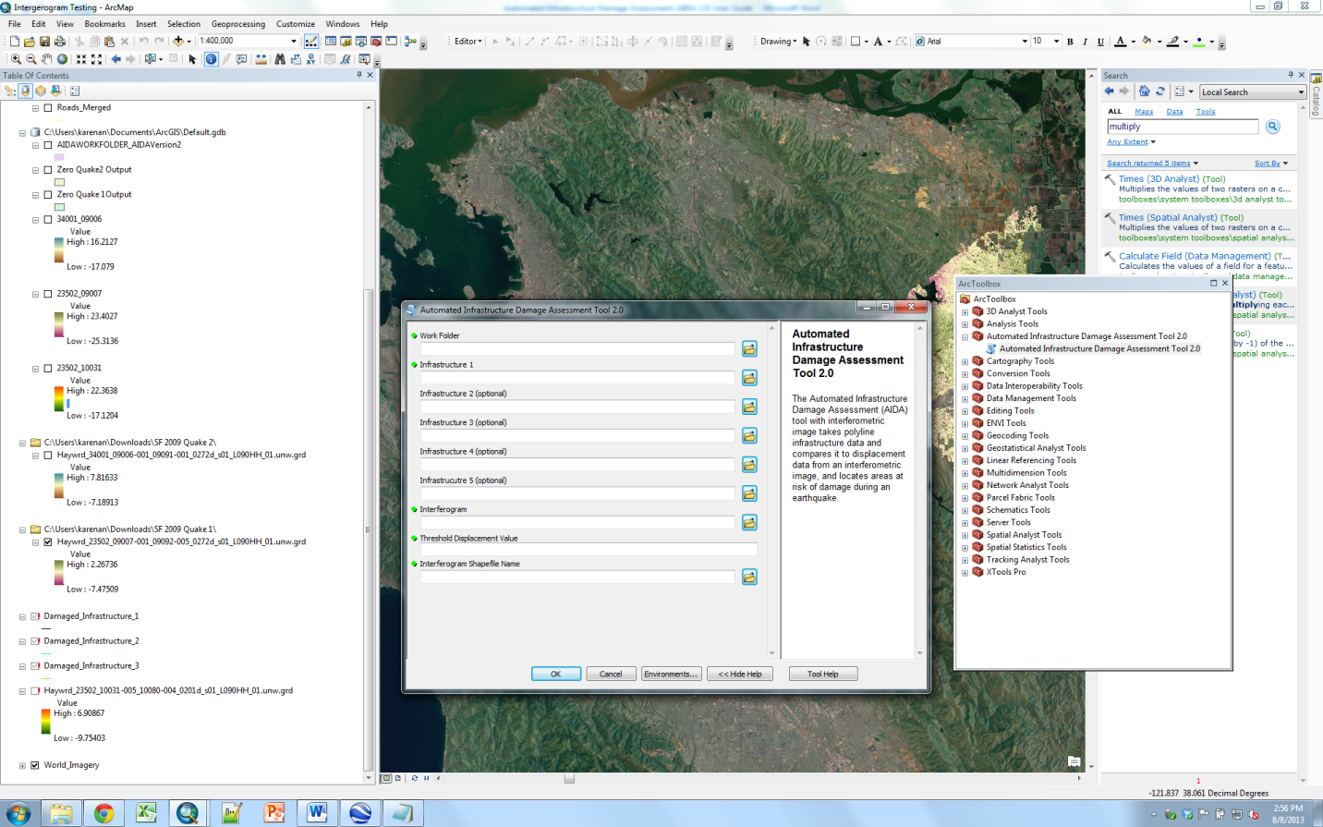

10. The output of this tool keeps only the pixels that contain the user defined threshold value or greater. Any infrastructure that intersects these pixels will be highlighted, as shown below. You can find the damaged infrastructure shapefiles in the work folder.

